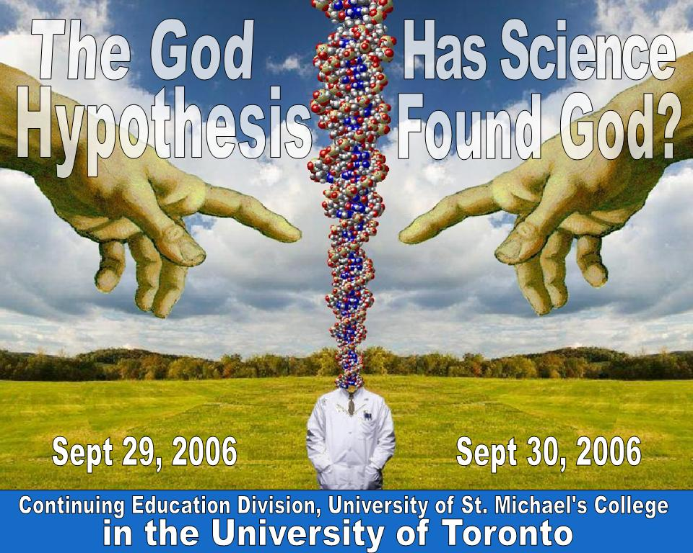

University of St. Michael's College

Continuing Education Anniversary Lectures

The God Hypothesis:
Has Science Found God?

- Friday, September 29, 2006 7:00 p.m. – 9:00 p.m.
- An Evening of Lecture and Discussion
No admission fee -- reservations recommended, Tel: 416-926-2247

- Saturday, September 30, 2006 9:00 a.m. to 5:00 p.m.
- A One Day Workshop: Lectures, Panel Discussions, Group Conversations

Fee: $100.00 (includes lunch)

121 St. Joseph Street, Alumni Hall, Room 400

- Friday Evening - September 29 – no admission fee

7:00 pm Science…and the Quest for Purpose By Dr David Humphreys, B.Sc., M.Sc. (London), Ph.D. (McMaster), F.C.I.C.
Professor Humphreys will present a thought provoking blend of experiments, demonstrations, and scientific insights
in his consideration of the way in which the molecules of life can give evidence of purposeful design

8:00 pm Have Astronomers Identified the Creator? By Dr Hugh Ross B.Sc. Ma.Sc. Ph.D.
Ours is the only generation that has witnessed the measuring of the Cosmos. What does this mean for our
questioning of creation? The current base of astronomical research also permits an ongoing testing of a cosmic creation model based on sacred religious texts.

- Saturday - September 30 - 9:00 a.m. - 5:00 p.m.

A day of Dialogue with Guest Lecturers and Panelists including

- Dr. Robert Mann, Chair, Dept. of Physics, University of Waterloo  - Ms Denyse O'Leary, Journalist, author of By Design or By Chance  - Dr. James R. Brown, MA, PhD, Professor, Department of Philosophy | - Dr. Dennis O'Hara, Director of Elliott Allen Institute for Theology and Ecology  - Dr. Hugh Ross, Ph.D., Astronomy  - Dr. Sehdev Kumar, Director, Forum for Dialogue between Science and Religion

We will discuss:

- Universal Darwinism and Intelligent Design  - What is Science? | - Is There Room for God in Scientific Dialogue?  - Astronomy and Human Destiny

Fee: $100.00 (includes lunch) Reservations: 416-926-7254 Email: continuinged.stmikes@utoronto.ca

For more information: please call Lynda at 416 229 2399 ext 125

